|  |  |
| --- | --- |
| **Lab Session** | **Topic** |
| 1 | Introduction to Threads - Pthreads |
| 2 | OpenMP – Basic programs such as Vector addition, Dot Product |
| 3 | OpenMP – Loop work-sharing |
| 4 | OpenMP – Sections work-sharing |
| 5 | OpenMP – Combined parallel loop reduction and Orphaned parallel loop reduction |
| 6 | OpemMP - Optimization (loop interchange, unrolling) and Profiling |
| 7 | Java RMI - Sample Demo |
| 8 | MPI – Basics of MPI |
| 9 | MPI – Point to Point Communication between MPI process |
| 10 | MPI – Non-Blocking Communication |
| 11 | MPI – Synchronization between MPI process |
| 12 | MPI – Collective Communication and Data Movement between MPI process |
| 13 | MPI – Collective Communication between MPI process |
| 14 | Introduction to CUDA, Array Processing using GPU |
| 15 | Vector and Matrix Processing using GPU |
| 16 | FAT LAB |

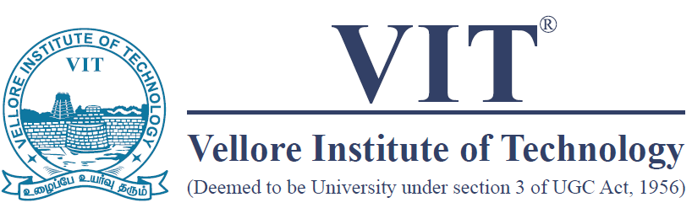

**School of Computer Science and Engineering (SCOPE)**

**Course Code: CSE4001**

**Course Title: Parallel and Distributed Computing**

**Semester: Fall 2022-23**